ITRW 222

Class test 10/ Klastoets 10

Name:________________________ Number:________

Question 1 / Vraag 1

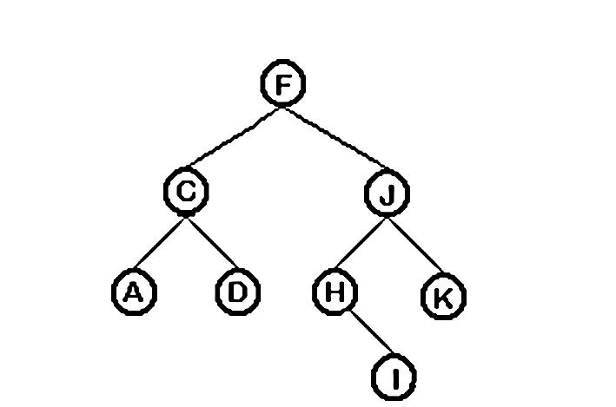

Gee die volgorde wat die volgende algoritmes deur die boom gaan beweeg:

Give the order in which the following algorithms will traverse the tree: (8)

|  |  |
| --- | --- |
| Preorder: |  |
| Postorder: |  |
| Inorder: |  |
| Breadth first: |  |